**How will we keep players engaged and coming back to play our game?**

**Endowment effect:**

Players will initially become invested in our game due to the endowment effect (ascribing value to things simply because you own them). Players will be able to name and customise their planet which gives them a sense of the planet belonging to them, causing players to feel an attachment to the planet they have created.

* Human thinking leads us to over value something the second we consider it to be ours
* We value things more when we own them
* The endowment effect can begin even before we own something. If we get very close to owning something, we already start treating it as though we own it, and mentally increase its value just as we’ll do once we officially own it.
* The endowment effect increases the more personally significant the item is (“sentimental value”)
* Not only can this meaning be invoked by your ownership, but can also be elicited simply by knowing that an item has history, even if you’re not part of that history (planet could have a back story? Before the player owned it)
* Giving players a ‘headstart’ with something makes them more likely to want to continue. When you give people a feeling of advancement towards a distant goal, they’re more likely to try harder and try longer to reach that goal – can give the player items to start off with & place on their planet so they have a starting point and feel like they have made some progress right at the start of the game
* Makes it seem like the task has already been undertaken: research shows that people are naturally motivated to complete tasks that they feel they’ve started and will want to remain consistent with previous intentions

**Forming Habits**

Notes from Hooked by Nir Eyal Chapter 5 (Investment):

* Small investments can turn unfamiliar actions into every day habits.
* Escalation of commitment – “The more users invest time and effort into a product or service, the more they value it. In fact, there is ample evidence to suggest that out labour leads to love.”
* We value things more highly if we have put effort into them

This means that the longer the user has spent putting time into creating and nurturing their planet, the more likely they are to keep playing. In order to convince the player to keep checking in on our game, we will need to turn the game into a habit for them – provide incentives to open the game regularly.

This can be done using the time based mechanics in our game, such as plants taking time to grow and other tasks on the planet taking a while to complete. The player will want to check when they are done so they can progress further.

The Habit Zone:

A product’s habit forming potential depends on two factors

* Frequency – how often the behaviour occurs
* Perceived utility – How usedul and rewarding the behaviour is in the user’s mind over alternative solutions

‘Vitamins’ vs ‘Painkillers’

* Painkillers solve an obvious need, relieving a specific pain, and often have quantifiable markets
* Vitamins do not solve a pain point. Instead they appeal to users’ emotional rather than functional needs – seeking pleasure

Hooked model (creating habits):

Trigger, action, variable reward, investment.

**Loss aversion:**

* Loss aversion is a human characteristic that describes how people are intrinsically afraid of losses.
* People dislike losing more than they like winning

How can we include this in our game?: Plants may wither/weeds might grow etc if the player does not take care of certain parts of their planet. Players will check in on the game often to avoid their planet becoming ruined over time.

**Compulsion loop:**

We will create a compulsion loop in our game, which is defined as “A habitual, designed chain of activities that will be repeated to gain a neurochemical reward: a feeling of pleasure and/or a relief from pain.”

There are 3 key notions:

1. Habitual – creating a long lasting and constantly repeated habit
2. Designed chain of activities – A set of specifically designed activities
3. Neurochemical reward (dopamine is released as a result of rewarding experiences)

A compulsion loop consists of:

* Assess – the player doesn’t want to waste their time on something that isn’t achievable.
* Choose – people like to choose and feel in control of their own destiny. If you give players a choice for how they want to proceed, they will be invested in the next step.
* Act – The player will act on that choice. This keeps the ‘story’ moving forward and the player at the centre of it. Their ‘critical role’ as actor will reinforce why they need to stay engaged.
* Reward – surprise the player with rewards. These keep players returning and staying in the core loop.

How to keep players in the loop:

BJ Fogg’s Behaviour Model

* A player needs to be an active participant in a game to keep them playing
* They need to take action and not simply watch the world pass them by
* Engagement is crucial
* Positive reinforcement to encourage the player to continue

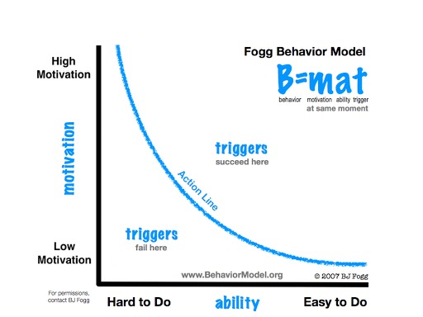

**Rewards**

* Reinforcer = Rewards given to the player, can be an outcome or a result
* Contingencies = A set of rules governing when rewards are given out
* Response = An action by the player that can fulfil the contingency

Ratios and intervals:

Ratio: How much of a reward to give based on an activity?

Interval: How long to wait between giving rewards for an activity?

Fixed Ratio Schedules:

* Ratio schedules provide rewards after a certain number of actions have been performed
* Ratio schedules typically produce a very distinct pattern in the participant: first there is a long pause, then a steady burst of activity as fast as possible until a reward is given
* The pause can be an issue as having a period of time where there is little incentive to play the game can lead to the player walking away
* Typically, the more amount of actions required, the longer the pause

Variable Ratio Schedules:

* A specific number of actions is required for a reward, but the number of actions required changes every time
* Participants typically respond with a steady flow of activity at a reasonably high rate (but not as high a rate as the burst under a fixed ratio schedule)
* More consistent and lacks pausing

Interval Schedules:

* Instead of providing a reward after a number of actions, can provide after a certain amount of time has passed
* In a "fixed interval" schedule, the first response after a set period of time produces a reward.
* There are also "variable interval" schedules, where the period of time involved changes after each reward. A counterpart to the variable ratio schedules, these also produce a steady, continuous level of activity, although at a slower pace.

Sources:

<http://www.mechanics-and-meeples.com/2013/05/28/psychology-of-gaming-loss-aversion/>

<http://www.psychologyofgames.com/2010/02/the-endowment-effect-and-used-game-sales/>

<http://www.gamasutra.com/blogs/JosephKim/20140323/213728/The_Compulsion_Loop_Explained.php>

<https://www.bigfishgames.com/blog/game-design-secrets-to-creating-irresistible-games/>

<http://www.gamasutra.com/view/feature/131494/behavioral_game_design.php>

Hooked by Nir Eyal (book)